Week # 01  
  
  
Professional Practice (IT)

Ethics in Information

Technology, Fourth Edition

Chapter 1

An Overview of Ethics

Ethics in Information Technology by Reynolds 5th edition

As you read this chapter, consider the following.

questions:

What is ethics, and why is it important to act according to a code of ethics?

Why is business ethics becoming increasingly important?

What are organizations doing to improve their business ethics?

Why are organizations interested in fostering good business ethics?

What approach can you take to ensure ethical decision making?

What trends have increased the risk of using information technology in an unethical manner?

**What is Ethics?**

**Moral code**

"Moral codes" refer to a set of guidelines or principles that dictate what is considered right or wrong behaviour within a society or community.

* Moral codes help us know how to behave and who we are.
* They come from our culture, religion, or what we think is right.
* Set of rules that tell us what's okay and help solve problems.

**Establishes boundaries of generally accepted behaviour**

"Establishes boundaries of generally accepted behaviour" means that moral rules define what actions are considered okay within a community.

**Why these rules?**

there are many sets of moral rules, but they can clash because different groups have different ideas about what's right.

**Morality**  
 "Morality" refers to principles or standards of what is considered right and wrong behaviour. It encompasses ethical principles, values, beliefs, and judgments about what is good or bad, virtuous, or immoral.

Morality guides individuals and societies in making decisions and interacting with others in a way that aligns with these principles. It can be influenced by cultural, religious, philosophical, and personal beliefs.

morality is based on shared understandings within society about what is considered right and wrong. These agreements form the foundation for established norms and principles that guide behaviour and interactions among people.

**Morality may vary by:**

* Age
* Cultural group
* Cultural background
* Religion
* Life experiences
* Education
* Gender

**Definition of Ethics**

**Ethics**

* Ethics is a system of beliefs concerning what is morally right or wrong in behaviour.
* Ethics often draw upon philosophical theories, cultural norms, and personal convictions(beliefs) to inform ethical judgments and behaviours.

**Virtues**

* Virtues are good habits that naturally make people want to do the right thing.
* They are ingrained(in-build) habits or tendencies that incline people towards doing what is considered right or good within a given society or moral framework.

**Vices**

* Vices are bad habits that lead to behaviour considered unacceptable or wrong.

Virtues and vices together form a personal moral framework. They represent the values and principles that guide an individual's decisions and actions, shaping their sense of right and wrong.

**The Importance of Integrity**

* Integrity(truthfulness/honesty), which is the quality of being honest and having strong moral principles, is fundamental to behaving ethically.
* integrity means sticking to the same moral standards no matter what they are.
* In essence, integrity serves as a central pillar or cornerstone(foundation) upon which ethical conduct is based.

**Act in accordance with a personal code of principles:** Individuals with integrity consistently follow their own set of moral values and principles in their actions and decisions.

**Extend to all the same respect and consideration:** They treat everyone with fairness, respect, and empathy, regardless of differences such as background, status, or beliefs.

**Apply the same moral standards in all situations:** They maintain consistency in applying their moral standards and principles across various circumstances and contexts.

**Unfortunately, consistency, difficult to achieve:** However, it can be challenging for individuals to consistently uphold their principles in every situation,

due to external pressures, conflicting interests, or personal biases

* Lack of integrity becomes evident(obvious) when moral standards are inconsistently applied based on the situation, or the people involved.
* When someone applies different rules depending on the situation or who's involved, it shows they lack integrity.

Many ethical problems are not as simple as right.

versus wrong

**The Difference Between Morals, Ethics, and Laws**

* **Morals:** one’s personal beliefs about right and wrong
* **Ethics:** standards or codes of behaviour expected of an individual by a group
* **Law:** system of rules that tells us what we can and

cannot do.

**Laws are enforced by a set of institution**s.

* Legal acts follow to the law.
* Moral acts follow to what an individual believes is the right belief of right and wrong.

|  |  |  |
| --- | --- | --- |
|  | **Ethics** | **Morals** |
| **What are they?** | The rules of conduct recognized in respect to a particular class of human actions or a particular group or culture. | Principles or habits with respect to right or wrong conduct. While morals also prescribe dos and don'ts, morality is ultimately a personal compass of right and wrong. |
| **Where do they come from?** | Social system - External | Individual - Internal |
| **Why we do it?** | Because society says it is the right thing to do. | Because we believe in something being right or wrong. |
| **Flexibility** | Ethics are dependent on others for definition. They tend to be consistent within a certain context but can vary between contexts. | Usually consistent, although can change if an individual’s beliefs change. |
| **The "Gray"** | A person strictly following Ethical Principles may not have any Morals at all. Likewise, one could violate Ethical Principles within a given system of rules to maintain Moral integrity. | A Moral Person although perhaps bound by a higher contract/agreement, may choose to follow a code of ethics as it would apply to a system. "Make it fit”. |
| **Origin** | Greek word "ethos" meaning "character”. | Latin word "mos" meaning "custom”. |
| Acceptability | Ethics are governed by professional and legal guidelines within a particular time and place. | Morality transcends (exceeds)cultural norms. |

**Sources of Ethical Norms**

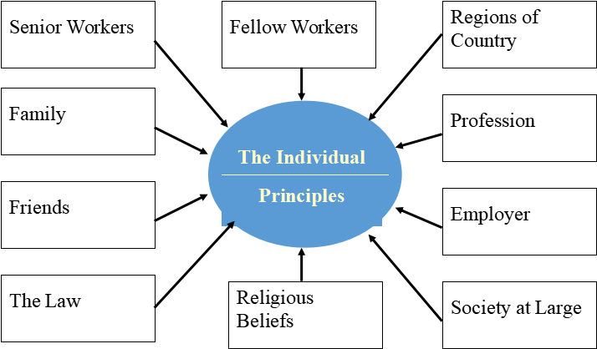

**Ethics and the Law**

* Laws establish the minimum standard of behaviour required by society.
* Compliance with the law signifies meeting the minimum legal requirements.
* Ethics go beyond the minimum requirements set by laws.
* They encompass broader moral principles and values.
* Ethics often represents a standard that exceeds the legal minimum.

Frequent Overlap

**Making Ethical Judgments**

**Ethics in the Business World**

Behavior or act that has been committed.

Fundamental norms of acceptability

Value judgments and perceptions of the observer

compared with

**Negative impact of inappropriate behaviour have increased:**

* In the past two decades, both the chances of inappropriate behaviour happening, and the harm caused by it have gone up.
* Many companies have been involved in unethical actions during this time.
* Some corporate leaders have faced consequences such as imprisonment(custody) due to their unethical behaviour.

**Several trends have increased the likelihood of unethical behaviour:**

* Globalization has made work environments more complicated, increasing the chances of unethical behaviour.
* Economic uncertainty has made it harder for organizations to stay profitable.
* This pressure to maintain profits can lead to unethical actions.
* Additionally, there's increased scrutiny(inspection) from employees, shareholders, and regulatory agencies, making it harder for unethical behaviour to go unnoticed or unpunished.

**Ethics in the Business World**

**Recent scandals in IT companies**

* **Satyam Computer Services (India)**

US-outsourced firm claimed wrong $1Billion assets, blacklisted, 53000 employee govt interaction.

* **Enron Unethical Decisions**

Over 22000 people with 101 billion dollar revenue, but exposed most of its shares are with partnership, share dropped $90 to less than $1.

* **IBM**

2011, bribe to China and Korea for sale, misconduct to US-stock exchange, $1Million fine pay to US security and exchange commission

Not just executives, but even lower-level employees, can find themselves in the middle of an ethical problem

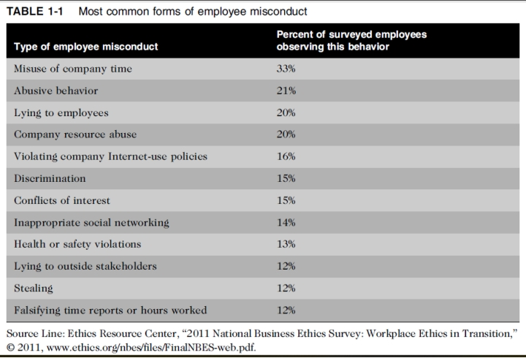

**Why Fostering Good Business**

**Ethics Is Important?**

* To gain the good will of the community
* To create an organization that operates consistently.
* To foster good business practices
* To protect organization/employees from legal action
* To avoid unfavourable publicity

**1: Gaining the Good Will of the Community**

* Companies have basic duties to society, often written in their official statements.
* These responsibilities include:
  + 1. to charities and nonprofits.
    2. Offering extra benefits to employees beyond what the law demands.
    3. Picking business opportunities that might help society even if they're not the most profitable.
* Socially responsible activities create good will.
* Good will makes it easier for corporations to conduct business.

The companies viewed as harmful may suffer a disadvantage.For example, a corporation that pollutes the environment may find opposing publicity, reduces sales, blocks relationships with some business partners, and attracts unwanted government attention.

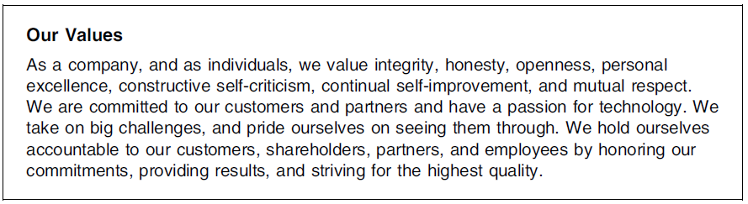

​

Microsoft’s statement of value

**2: Creating an Organization That Operates Consistently**

* Consistency is essential for building a strong organizational culture.
* It helps employees understand expectations and use company values in decision-making.
* Consistency also enables stakeholders like shareholders, customers, suppliers, and the community to know what to expect from the organization.

**Many companies share the following values:**

* Operate with honesty and integrity, staying true to organizational principles.
* Operate according to standards of ethical conduct, in words and action.
* Treat colleagues, customers, and consumers with respect
* Strive to be the best at what matters to the company.
* Value diversity (variety) Make decisions based on facts and principles.

**3: Fostering(adopting) Good Business Practices**

* Good ethics means good business/improved profits.

1. Retain customers even in competition with competitors.

* Companies that Produce safe and effective products
  + 1. Avoid costly recalls and lawsuits (court case).
    2. Provide excellent service that retains customers.
    3. Develop and maintain strong employee relations.
    4. Suffer lower turnover rates.
    5. Enjoy better employee morale.
* Suppliers/business partners place priority on working with companies that operate in a fair and ethical manner.

**3: Fostering(adopting) Good Business Practices**

* Bad ethics means bad business/waning profits. Bad ethics can lead to bad business results.

Bad ethics can have a negative impact on employees.

* **A discrepancy(differences) between employee and organization:**

Destroys employee commitment to organizational goals and objectives.

Creating low morale leads to poor performance.

Reduce employee involvement in organizational improvement initiatives.

Builds indifference to the organization’s needs.

​

4. **Protecting the Organization and Its Employees from Legal Actions**

* In 1909, U.S. Supreme Court established that an

employer can be held responsible for the acts of its

employees

* This principle is called ***respondent superior.***
* Coalition of several legal organizations debates.

establishment for ethics and compliance programs to

reduce criminal liability of organization.

* Others claim *company officers should not be given light sentences* if their ethics programs are ineffective.